Using Eleos + Collaborative Documentation (CD)
(Three versions: child, teen, adult)

THE CORE PROCESS (same for all ages)
1. Start Eleos at the beginning of the session.
Eleos quietly captures:
- Themes
- Interventions
- Client language
- Emotional tone
- Key moments
Script to introduce Eleos to clients (with bonus quick parent engagement practice that takes seconds)
We’ll be using an app called Eleos during session to help with notetaking so I can stay fully present and engaged in our work together. At the end of session, I’ll turn the note-taker off and we’ll briefly review what felt helpful, schedule our next session, and talk through homework or skills to practice during the week.
Pro tip: If you assign homework for a child or teen, text the parent while walking the student back to class or while walking to pick up your next student. Let them know what was assigned, invite them to support practice during the week, and encourage them to reach out with any questions.

2. At the 45–50-minute mark, stop Eleos.
Say:
“I’m going to turn off the note taker so we can wrap up and finish your note together.”
3. Switch into Collaborative Documentation for the last 5–10 minutes.
Together, you fill in:
- Client’s summary of the session
- Their progress toward goals
- Their plan for the week
- Any safety updates
- Any interventions you used
- Next session focus
4. Eleos + CD now gives you 95–100% of the note.
Eleos provides the structure and draft.
CD fills in the client’s voice and the clinical reasoning.
You finalize the note in under 2 minutes after the session.
AGE-SPECIFIC WORKFLOWS
KIDS (5–10)
Goal: Keep them engaged while you finish the note.
1. Start Eleos at the beginning.
Run it through the whole session.
2. At the end, stop Eleos and give the child a simple task:
- A drawing
- A feelings chart
- “Show me what calm looks like”
- “Draw what we practiced today”
3. While they draw, ask one simple reflection question:
- “What did you learn today?”
- “What should we work on next time?”
4. Add their words + your clinical summary into the note.
Eleos gives you the draft.
You add:
- Their quote
- Their progress
- Their plan
Result:
Note is 95–100% complete before they leave the room.
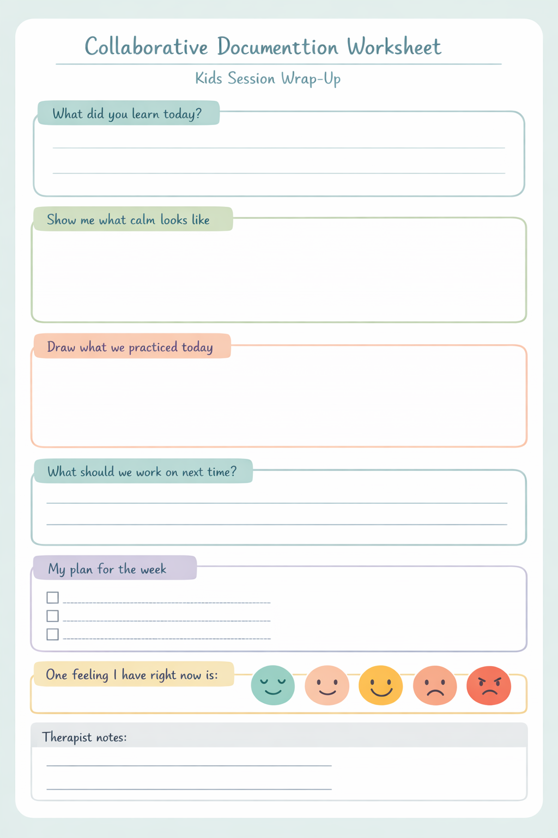
TEENS (11–17)
Goal: Use their voice to strengthen buy-in and accuracy.
1. Start Eleos at the beginning.
2. At the end, stop Eleos and ask 2 quick prompts:
- “What’s one thing you’re taking away from today?”
- “What should I write down as your goal for next week?”
3. Type their answers in front of them.
Teens like seeing the note being written — it feels transparent and collaborative.
4. Add your clinical reasoning + interventions.
Eleos already captured:
- Themes
- Skills practiced
- Emotional shifts
You add:
- Progress
- Plan
- Risk
- Next steps
Result:
Note is essentially finished when the teen walks out.

ADULTS
Goal: Use CD as a therapeutic intervention.
1. Start Eleos at the beginning.
2. At the end, stop Eleos and invite reflection:
- “What’s your biggest takeaway from today?”
- “What do you want to focus on next week?”
- “What should I include in your note about your progress?”
3. Write the note together.
Adults appreciate:
- Transparency
- Shared ownership
- Seeing their progress in writing
4. Add your clinical reasoning + risk assessment.
Eleos gives you the skeleton.
CD fills in the client’s voice.
You add the clinical frame.
Result:
Note is 100% complete before the client leaves.

THE SIMPLE FORMULA (universal)
Eleos = the draft
Client = the meaning
You = the clinical reasoning
Put those together in the last 5–10 minutes, and the note is done.

